Testing the Four-Phase Interest Development Survey for Chemistry

Joseph E Michaelis, Sally P.W. Wu, Martina A. Rau, Mitchell J. Nathan

University of Wisconsin-Madison
Table 1. FID-CS items
- I enjoy learning about chemistry even when it is very difficult. (PER)
- I know way more about chemistry than other students I know. (KNOW)
- I think about my own questions about chemistry that are not for required for class at least once a week. (QUES)
- Compared to other students, I am way better at doing chemistry work. (SE)
- Knowing about chemistry is extremely valuable to me. (VALUE)
- I work on chemistry projects or learning chemistry that is not required for class at least once a week. (CE)
- I know a lot about the chemistry topics that I find interesting. (KNOW)
- I think everyone should know a lot about chemistry (VALUE)
- I'm inspired to learn more about chemistry on my own when I see something in chemistry that interests me. (PER)
- I always learn more about chemistry on my own if I find it interesting (QUES)
- When chemistry interests me, I am confident that I can learn about it extremely easily. (SE)
- When I'm working on something in chemistry that I think is interesting, I continue working even when it takes a lot of time. (PER)
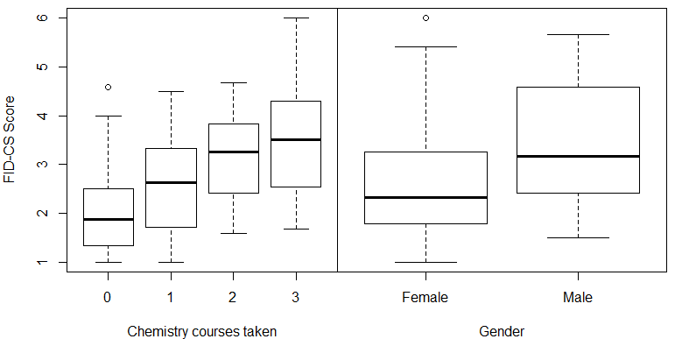

Fig. 1. Distribution of FID-CS scores (left) and FID-CS scores
by total chemistry courses (right)

Table 2. Mean scores for various FID scales by age group and content area
Domain & Study Type | Ages | Mean  (SD) | N | α | Distribution
Chemistry:  Educational Psychology Students in a lab study using a chemistry intelligent tutoring system | College | 2.72  (1.11) | 158 | 0.88 | 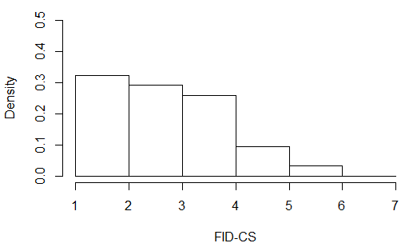
Domain & Study Type | Ages | Mean  (SD) | N | α | Distribution
Reading:  Children reading with educational robot or control condition (2017 & 2018 combined) | 10 – 12 | 5.46  (1.03) | 32 | 0.88 | 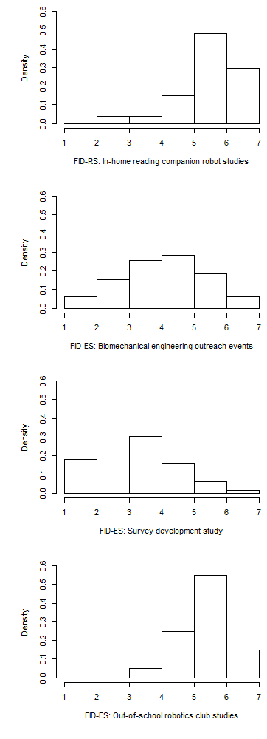
Engineering:  Visitors to Biomedical Engineering outreach event  (2017 & 2018 combined)  *Shortened survey | K – 8th | 4.41  (1.08) | 1552 | 0.81
Engineering:  Students in survey evaluation study  (2016) | High School | 3.23  (1.21) | 145 | 0.91
Engineering:  Students in an out-of-school FIRST Robotics competition club (2016) | High School | 5.33  (0.76) | 20 | 0.83
- Four-Phase Interest Development Surveys (FID) are valid, reliable, and adaptable measures of interest.
- Suited for identifying relative interest level for differentiating or scaffolding activities by student interest.
- We provide regular updates for means and distributions: www.bit.ly/steminterest

